DRAFT Minutes of the Little Hoole Parish Council Meeting  Held at 7pm on Monday 11th May 2026, at Walmer Bridge Village Hall  In attendance: Cllrs L Dryden (Chair), S Evald, E Moore, D Owen. T Wilcock, J Rainsbury, and S Rainsbury.  Mr P Cafferkey (Clerk & Responsible Financial Officer).  3 members of the public. | 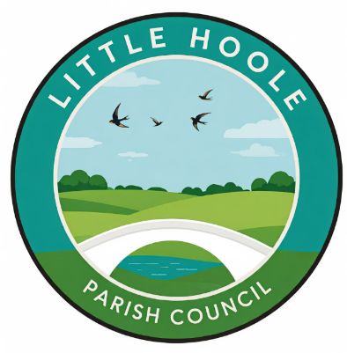
- Apologies for absence. None.
- To agree the minutes of the last Parish Council mtg. It was resolved that the minutes of the meeting held on 13th April 2026, be accepted as a true record and were agreed unanimously.
- To receive declarations of interest. Cllrs Moore and Owen declared a non-pecuniary interest in item 7.
- Matters arising from the minutes of last meeting. None
- Public Time - matters raised by members of the public. A member of the public questioned the status of public right of way FP0707050 (corner of Gill Lane and the A59). The Clerk confirmed an update would be sought from Lancashire County Council.
James Walsmsley attended on behalf of Little Hoole and Friends Ground Force (Little Hoole Primary School) outlining the work they are doing to the outside areas of Little Hoole County Primary School, with a view to submitting a grant application to the Parish Council.
Kirsty Clarke was in attendance to provide an outline of the request for grant funding on the behalf of Little Hoole Primary School Parent Teachers Association (item 7 refers).
- Planning Applications.
  - 07/2026/00292/HOH. Brookroyd Gill Lane Longton PR4 5GN. Raising of ridge height and rotation of roof 90-degrees to create first-floor accommodation with gable roof and single storey rear extension.
  - 07/2026/00262/CLD. 83 Tillage Close Walmer Bridge PR4 5BZ. Certificate of Lawfulness for a garage conversion.
  - 07/2026/00274/HOH. 17 Dob Lane Walmer Bridge PR4 5QL. Loft conversion (front and rear dormer extensions) and new front porch. Render whole building.
  - 07/2026/00246/DIS. West Field Moss Lane Little Hoole PR4 4TA. Discharge of condition 5 pursuant to permission 07/2023/00442/FUL for demolition of stables and the erection of a bungalow.
  - 07/2026/00242/FUL. Bakers Farm Brook Lane Little Hoole PR4 5JB. Retrospective conversion of existing stable block to a bed and breakfast facility
There were no objections to the above planning items.
- Grant application from Little Hoole Primary School PTA in the sum of £4,099 towards the estimated total cost of £12,298 for provision and installation of new lighting and sound system in the school hall. It was resolved that this application be refused on the basis that there was insufficient evidence, at this stage, that the equipment would benefit the wider community.
- To approve the following transactions in the bank for April 2026.
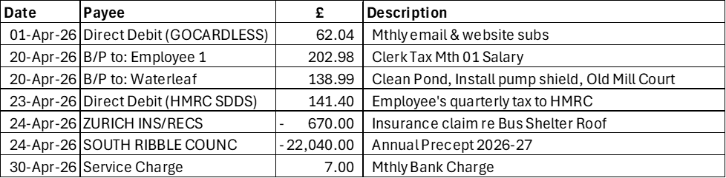
It was resolved that the above transactions be approved.

- Payments approved by email or pre-approved and retrospectively noted. None
- Payments for approval. It was resolved that the following payments be approved:.
  - Clerk’s claim for April 2026 (18.08 hours & postage of £3.80).
  - LALC annual subscription 2026-27 £434.04
  - Clerk’s purchase of black printer cartridges (2 no.) £20.82 (excl VAT.)

- To note the previously approved Parish Council Budget for 2026-27. The Clerk confirmed the previously agreed budget; a gross expenditure budget of £28,718, a gross income budget of £26,440 giving a net deficit budget for 2026-27 of £2,278; the deficit to be funded from reserves.
- VAT Claim 2024-25. The Clerk reported that he had submitted the VAT Claim for 2024-25 to HMRC in the sum of £1,009.44.
- To receive and note the Internal Auditor’s report for 2025-26. The Clerk presented the previously circulated Internal Auditor’s AGAR Audit report and detailed report. The report was positive. The only negative matter reported being that, due to an oversight by the Clerk, the External Auditor Report and Certificate for 2024-25 had not been published on the Parish Council’s website. This has now been rectified and the Internal Auditor reported that this was “a minor omission in the context of otherwise strong compliance”.
- Approval of:
  - Section 1 of the Annual Governance & Accountability Return (AGAR) 2025-26 – Annual Governance Statement 2025-26. It was resolved that this be approved.
  - Section 2 of the AGAR 2025-26 – Accounting Statements 2025-26 It was resolved that this be approved.
  - The Clerk/RFO & Chairman to sign the AGAR on behalf of Little Hoole Parish Council. Section 1 of the AGAR was signed by the Chair and Clerk. Section 2 of the AGAR was signed by the Chair. As is required procedure, Section 2 of the AGAR had been signed by the Clerk on the 9th May 2026 i.e. prior to presentation to the Parish Council for approval.
- Verbal report on meeting with MP Mr Paul Foster re Town & Parish Council Forum held on 17th April. The Chair and Cllr Evald that they had attended this meeting at the offices of SRBC on the behalf of the Parish Council. The meeting was well attended and informative. It is likely that these meetings will be held every 6 months.

- Review and approval of the Parish Council’s Grants Policy. It was resolved that, following the correction of a few minor errors, the Parish Council’s Grants Policy be approved.
- Update: re the replacement of the two bus shelters at the junction of Liverpool Old Road and Liverpool New Road (Star Garage) at a cost of £15,942 (excl VAT). No progress since last month i.e. the Chair is finding it difficult to obtain a response from South Ribble Borough Council.
- Update re Memory Bench. The Chair reported that, as with last month, he is still waiting for quotes for a base for the bench. He has provided contractors with the required details, but has not yet received any responses.
- Update re Pedestrian Access to Longton Health Centre & Library. The situation remains the same as the last couple of months, in that the Chair has emailed NHS Property Services, but as yet, still no response.
- Update re tree carving on Dob Lane Recreation Park. Cllr Evald reported that the work for the tree carving has been awarded to Mr Andy Burgess; the work will be undertaken in June.
- Update re Insurance Claim. The Clerk confirmed that he has managed to secure payment from Zurich Insurance with regard to the Parish Council’s claim for the damage to the bus shelter roof.
- To approve the Parish Council’s insurance for 2026-27 as from 1 June 2026. The Clerk distributed a summary showing a number of insurance scenarios, but responses were still awaited from Gallagher Insurance and Clear Councils Insurance. It was resolved that a decision would be made by email prior to the June meeting, once other quotes have been received, as the date for renewal is the 1st June 2026.
- To discuss proposal for a reserves policy including a “self-insurance” reserve. It was agreed that this would be a future agenda item.
- Update re Dog Fouling. Cllr Evald reported that the display of posters encouraging dog owners to clean up after their dogs is to go ahead. The possibility of a post with free “dog poo” bags to be located on The Green was found to be too costly as SRBC required a planning fee of nearly. £1,000.
- Summer Activities Programme – Update. Cllr Wilcock reported that she has had difficulty getting quotes from other contractors other than those used last year. Discussion took place around renting a bigger generator as last year not all the inflatables were in use at the same time due to the small size of the generator. If a larger generator could be hired, paid for by the Parish Council, then Bouncelona had indicated that they could provide more inflatables at no extra cost. Better advertising of the event, also including a banner and face painting were discussed.
- Fault on Zip Wire. The Zip Wire has been repaired by SRBC.
- Update - Summer Planting. The Summer Planting is to go ahead at the end of May.
- To agree locations for future Parish Council Meetings. It was resolved that future parish Council meetings would be held at Old Mill Court, as from when this can be conveniently arranged by the Clerk.
- Information and Updates. This item is purposefully not recorded; it is to allow Councillors a short time to discuss any matters that might result in a future agenda item. No financial or legal decisions are made.
- Correspondence. An email had been received from a member of the public stating that a Post Box had been removed from Station Road. The Clerk agreed to contact Royal Mail.
- Date & Time of Next Meeting. It was agreed that the next meeting is to be held on Mon 8th June 2026, 7pm. Location: Walmer Bridge Village Hall, in the Lounge.

